

People's Democratic Republic of Algeria
Ministry of Higher Education and Scientific Research

Houari Boumediene University of Science and Technology
Faculty of Computer Science
Université des Sciences et de la Technologies Houari Boumediene
Faculté d’informatique
Data mining
Lab 4 Raport

Visual and Quantitative Comparison of Clustering Algorithms

4th year : Software Engineering

Submitted by :
- Mesgui Alae
- Nait Cherif Sabrinel

Submission Date : 21.12.2025
Table Of contents
People's Democratic Republic of Algeria 0
Lab 4 Raport 0
Visual and Quantitative Comparison of Clustering Algorithms 0
I. Introduction 4
II. Lab Objective 4
III. Application Architecture 4
i. Technologies Used 4
ii. Modular Structure 5
IV. Implemented Features 5
i. Data Preview 5
Data Loading 5
Data Preview 5
ii. Preprocessing 6
iii. Clustering 7
Implemented Algorithms: 7
Analysis Tools 7
Results Export 7
iv. Classification 7
Implemented Algorithms: 7
Classification Process 8
Resultat Display: 8
V. User Interface 9
Welcome Tab 9
Preview Tab 10
Preprocessing Tab 11
Clustering Tab 13
Classification Tab 16
Results Tab 18
VI. Conclusion 18

Introduction

Data mining is an analytical approach aimed at extracting relevant and novel information from large datasets. Clustering, a fundamental technique in unsupervised data mining, enables grouping similar data without prior knowledge of categories.
This report presents DMI, an advanced interactive application developed in Python to visually and quantitatively compare different clustering algorithms. The application provides a comprehensive platform for data preprocessing, algorithm comparison, and result visualization.

Lab Objective
The main objective of this practical work is to:
- Compare multiple clustering algorithms (K-Means, K-Medoids, DBSCAN, Agglomerative, Diana)
• Implement classification algorithms (KNN, Decision Tree, Naive Bayes, SVM)
- Visualize clustering results interactively in 2D and 3D
- Evaluate algorithm performance quantitatively using standardized metrics
- Provide an ergonomic interface enabling data preprocessing and analysis
- Support multiple data formats and predefined datasets

Application Architecture

Technologies Used
- Language: Python 3.x
- Graphical Interface:
- Tkinter (main GUI framework)
- ttk (themed widgets)
- Analysis Libraries:
- pandas: data manipulation
- numpy: numerical computations
- scikit-learn: clustering algorithms and metrics
- scipy: statistical and hierarchical analysis
- pyclustering: K-Medoids implementation

- Visualization:
- matplotlib: 2D/3D graphics
- FigureCanvasTkAgg: Tkinter integration
- mpl_toolkits.mplot3d: 3D visualization support

Modular Structure
The application is organized into five main tabs:
- Welcome: Application introduction and quick start guide
- Preview: Data loading, exploration, and initial statistics
- Preprocessing: Data cleaning and transformation operations
- Clustering: Algorithm selection, execution, and visualization
- Classification: Supervised learning with multiple algorithms
- Results Tab: Comprehensive analysis and summary statistics

Implemented Features

Data Preview

Data Loading
Supported sources:
- Custom CSV files
- Predefined datasets (Iris,Wine,Blobs)

Data Preview
Data Head Tab:
- First 10 rows display in scrollable table
- All columns visible with horizontal scrolling
- Column headers with truncation for long names
Info & Stats Tab:
- Dataset Info Panel:
- Column names
- Data types (int64, float64, object)
- Missing value counts per column
- Statistics Panel:
  - Minimum, Maximum values
  - Quartiles (Q1, Median, Q3)
  - Mean and Mode
  - Available only for numeric columns

Preprocessing
1. Categorical Data Conversion:
- One-Hot Encoding: Creates binary columns for each category
- Label Encoding: Assigns numeric labels to categories
- Automatic detection of categorical columns
- Feedback on converted columns
2. Missing Values Handling:
- Mean Imputation: Replace with column average
- Median Imputation: Replace with column median
- Mode Imputation: Replace with most frequent value
- Drop Columns: Remove columns with >60% missing values
- Column-wise processing with detailed reporting
3. Duplicate Handling:
- Detection of duplicate rows
- User confirmation before removal
- Count of removed duplicates
- Data integrity preservation
4. Feature Scaling:
- Min-Max Scaling
- Z-Score (Standard) Scaling
- Applied to all numeric columns
- Essential for distance-based algorithms
Preprocessing Results Display:
- Real-time feedback in text widget
- Operation history tracking
- Scrollable results panel
- Clear separation between operations

Clustering

Implemented Algorithms:
- K-Means
- K-Medoids
- Agglomerative (AGNES)
- Diana
- DBSCAN

Analysis Tools
1. Elbow Method:
- Tests K values from 1 to 10
- Plots inertia vs. number of clusters
- Helps determine optimal K
- Interactive plot with grid
2. Dendrogram:
- Hierarchical tree visualization
- Uses Ward linkage method
- Samples up to 100 points for performance
- Shows cluster formation process

Results Export
Export Capabilities:
- Save cluster labels to CSV
- Preserves latest clustering result
- User-selected file location
- Default filename: cluster_labels.csv
- Error handling for file operations

Classification

Implemented Algorithms:
- KNN (K-Nearest Neighbors)
- Decision Tree
- Naive Bayes (Gaussian)
- SVM (Support Vector Machine)

Classification Process
- The system stores the original (non-normalized) target values
- Prevents data leakage from preprocessing operations
- Checks for missing values in target column
- Ensures at least 2 classes present
- Detects continuous targets (>20 unique values) and rejects them
- 70% training, 30% testing (test_size=0.3)
- Random state = 42 for reproducibility
- Uses original target for training/testing
- Features: all numeric columns except target

Resultat Display:
Classification Results Table:
- Algorithm name/Accuracy score /Target column used
Confusion Matrix Visualization

User Interface

Welcome Tab
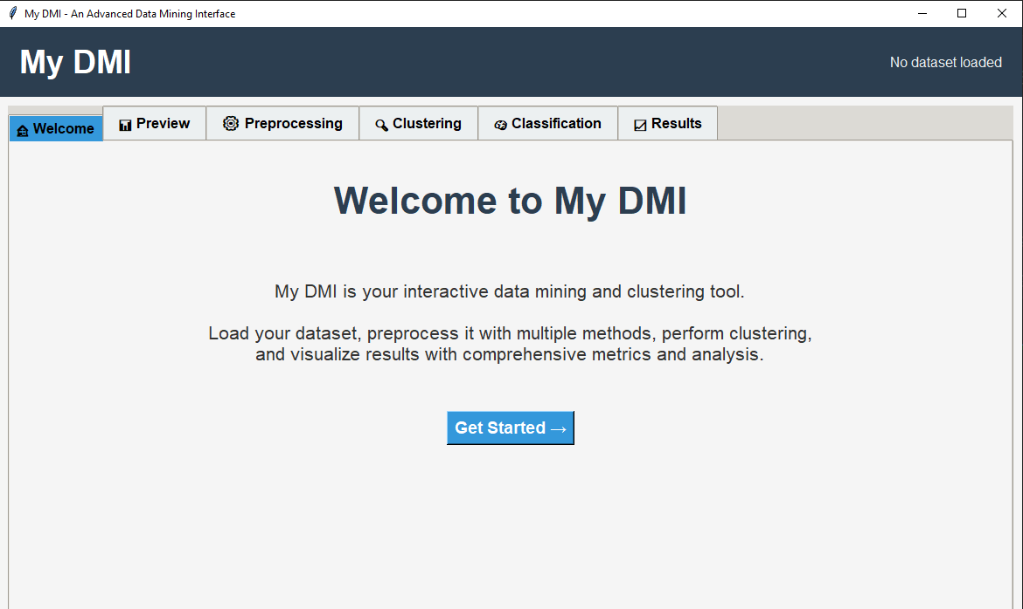

Preview Tab

Data Loading Panel

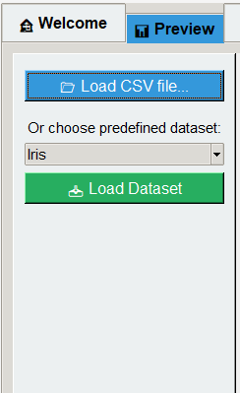

Data Head View

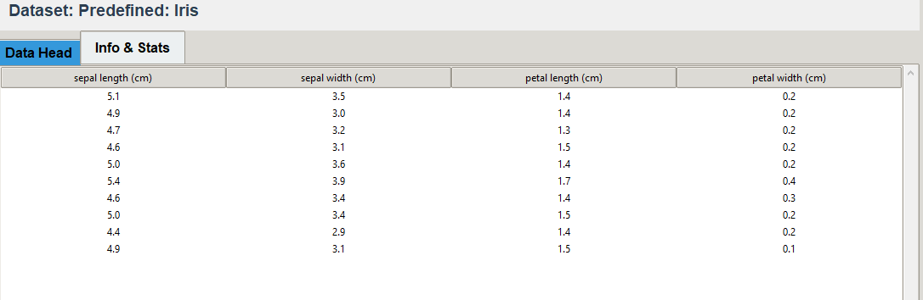

Info & Stats View

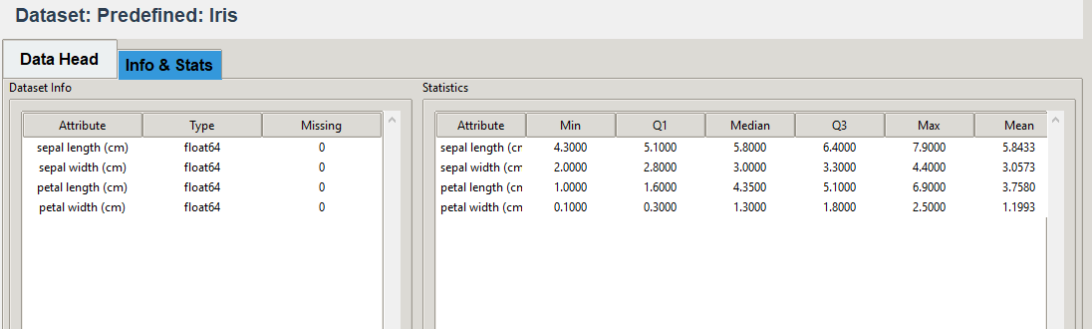

Preprocessing Tab

Preprocessing Controls

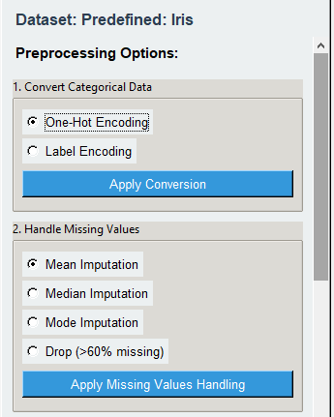
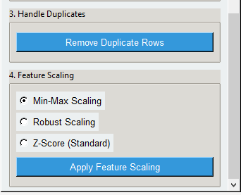

Preprocessing Results Display

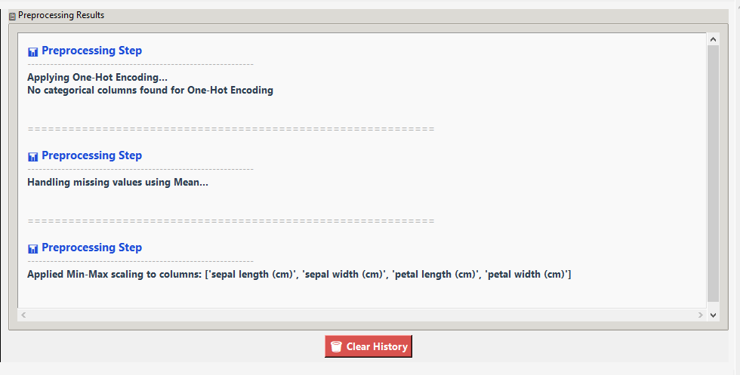

Clustering Tab

Algorithm Selection

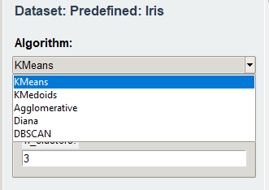
Example:
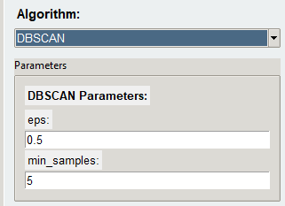

2D Clustering Visualization

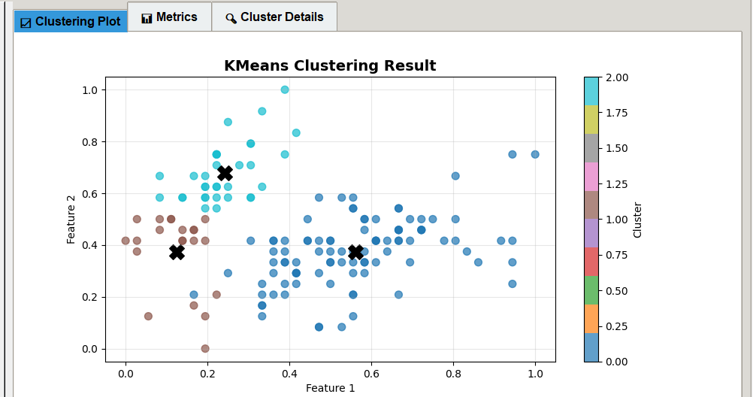

3D Clustering Visualization

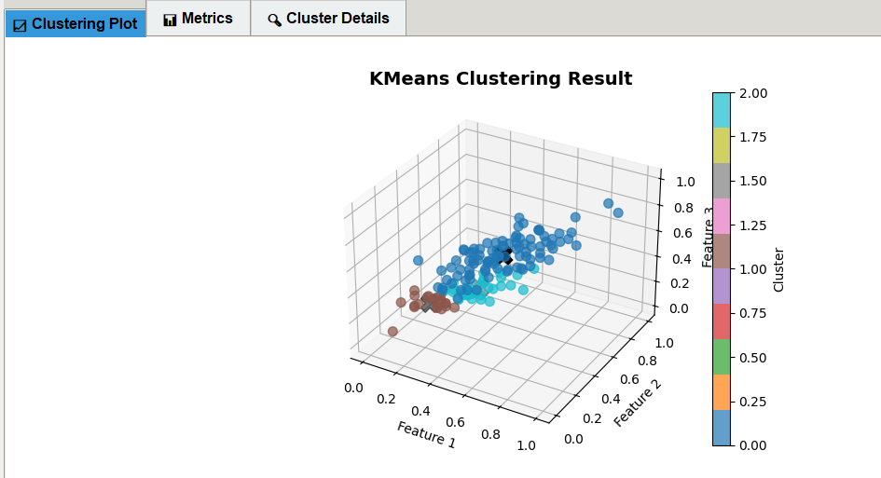

Metrics Table

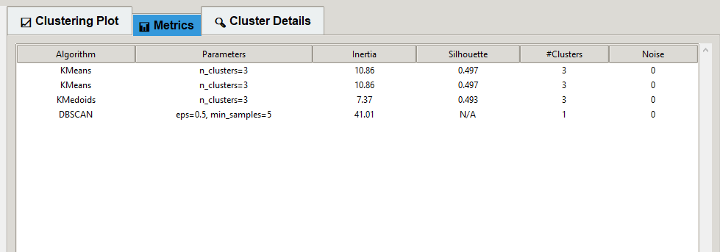

Latest Cluster Details

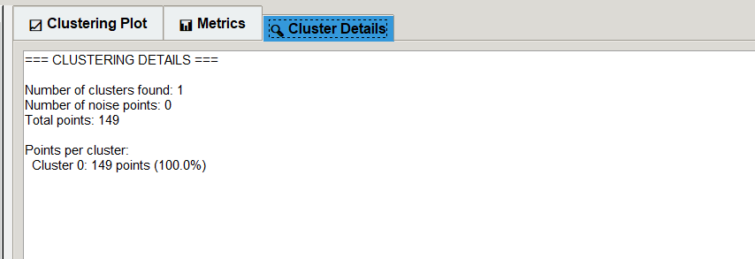

Analysis Tools
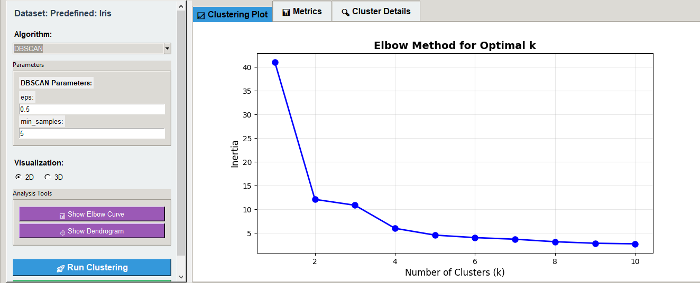

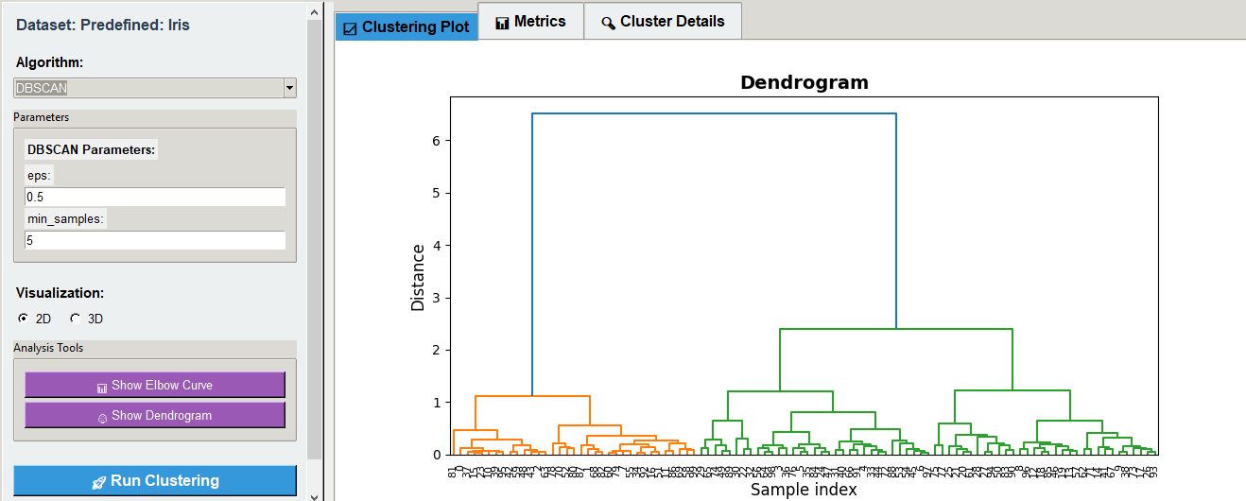

Classification Tab

Algorithm Selection

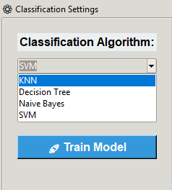

Target column Selection
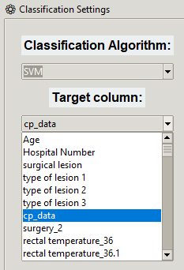

Classification results

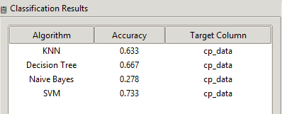

Classification visualisations

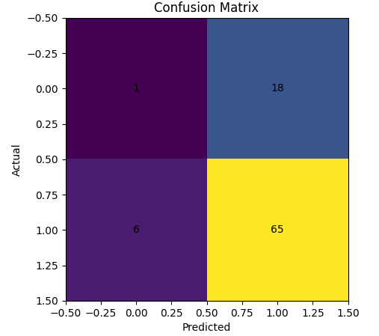

Results Tab

Dataset Summary
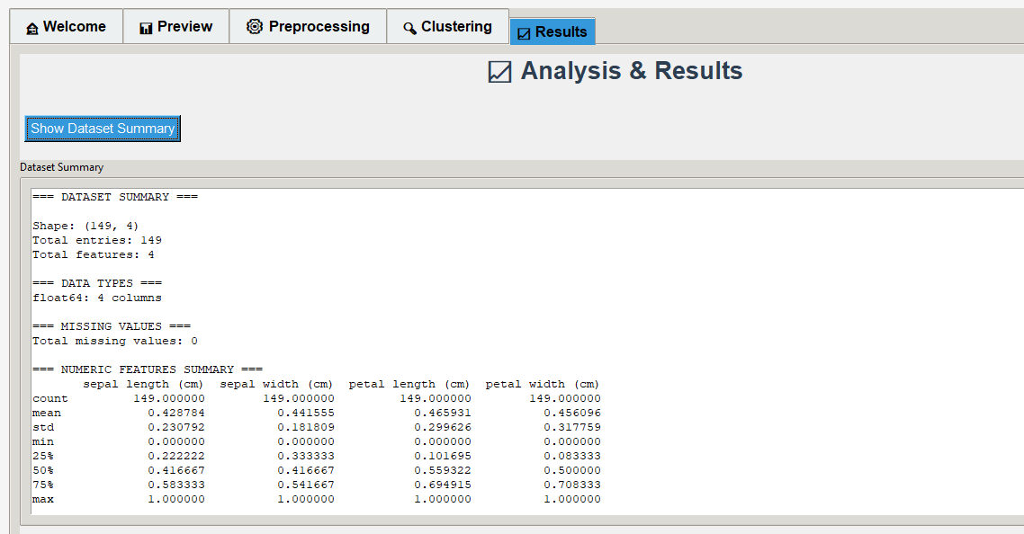

Conclusion
My DMI is a comprehensive data mining platform that successfully combines clustering and classification capabilities. The application provides an intuitive interface for data preprocessing, algorithm comparison, and result visualization, making it both an effective educational tool and a practical solution for data analysis tasks.

